Austraits database submission method.

Brief site description
This study was conducted in Kosciuszko National Park, NSW, the lands of the Ngarigo and Walgalu people, and a part of the Australian Alpine Bioregion. The study locations were Mt Stilwell and Schlink Pass (Figure 2).
At each location, there were eight sites, paired by aspect, with four North-West facing sites and four South-East facing sites: 16 sites in total (Table 1). The sites were also at least 100 metres apart, but at similar elevations within a given location to ensure that any environmental differences between the sites in each pair were not due to elevational influence on temperature (Scherrer & Körner, 2011). Five Schlink Pass sites did not align strictly with NW and SE due to the curvature of the landscape following the creek (Figure 3). In these cases, we grouped sites with NW or SE based on the temperature influence of morning vs afternoon sunlight. Sites tending towards West or South-West were grouped with NW, with more Easterly sites grouped with South-East.

Table 1. The latitude, longitude, elevation and aspect for the 16 study sites surveyed over 12 days. Eight of these sites are located at Mt Stilwell, the ridgeline, and eight at Schlink Pass, the frost hollow.
Site code | Latitude (º) | Longitude (º) | Elevation (m a.s.l) | Aspect
Mt Stilwell
StCbNW | -36.4427 | 148.3301 | 1962 | NW
StCbSE | -36.4448 | 148.3343 | 1953 | SE
StCNW | -36.4420 | 148.3279 | 1955 | NW
StCSE | -36.4458 | 148.3327 | 1955 | SE
StAmrfNW | -36.4423 | 148.3263 | 1959 | NW
StAmrfSE | -36.4477 | 148.3321 | 1956 | SE
StSpNW | -36.4412 | 148.3227 | 1955 | NW
StSpSE | -36.4413 | 148.3235 | 1961 | SE
Schlink Pass
SpAmrfNW | -36.2647 | 148.3733 | 1678 | NW
SpAmrfSE | -36.2645 | 148.3730 | 1685 | SE
SpMrW | -36.2670 | 148.3717 | 1671 | W
SpMrE | -36.2668 | 148.3716 | 1670 | E
SpRbNW | -36.2689 | 148.3707 | 1668 | NW
SpRbSE | -36.2686 | 148.3713 | 1665 | SE
SpRcSW | -36.2682 | 148.3714 | 1667 | SW
SpRcE | -36.2678 | 148.3711 | 1670 | E

Data collection
The main sampling trip was conducted in January 2025. The main trip consisted of 12 days of sampling, six days at each location, giving six replicate sampling days for each of the 16 sites (96 sampling surveys in total; Figure 3). All the sampling was completed as close together in time as possible within a 3-week period, with the 12 sampling days interspersed with three days off. To avoid any influences of sampling time-of-day that might bias site variation in the data, the order that sites were visited was altered each time that a location was sampled, ensuring that each site was visited at a different time of day each time. The sampling itself was weather dependent, and only took place when it was not raining, as insect visitors have reduced activity during rainy weather (Lawson & Rands, 2019).

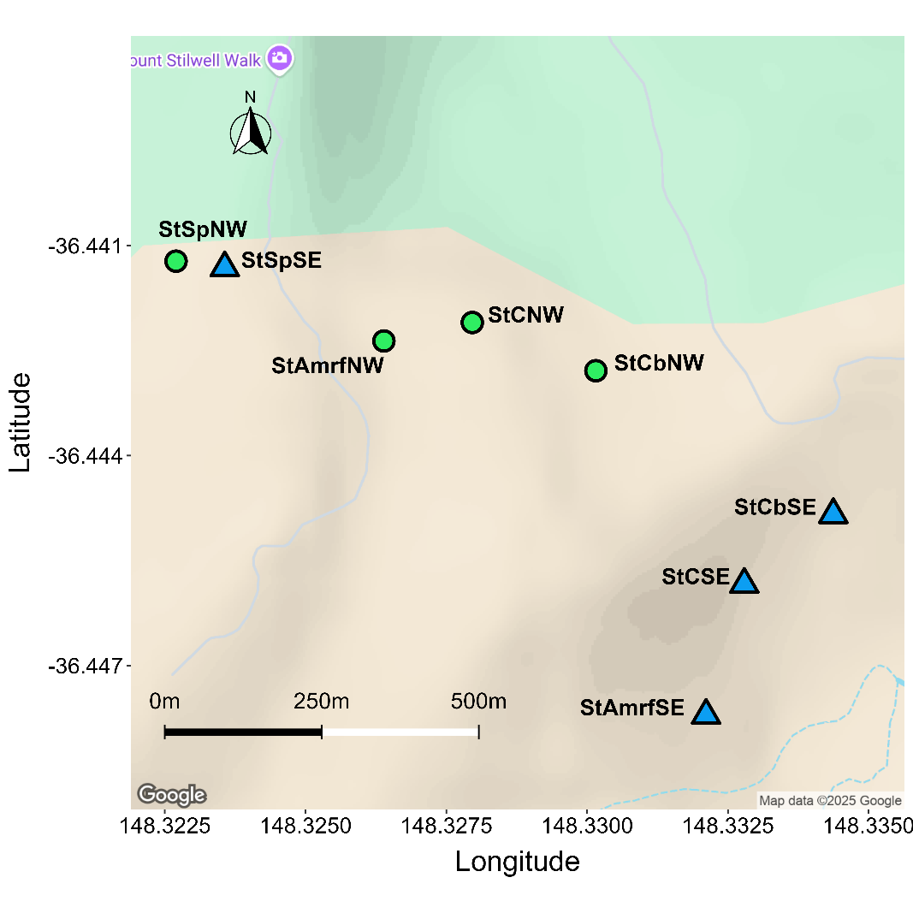  a | 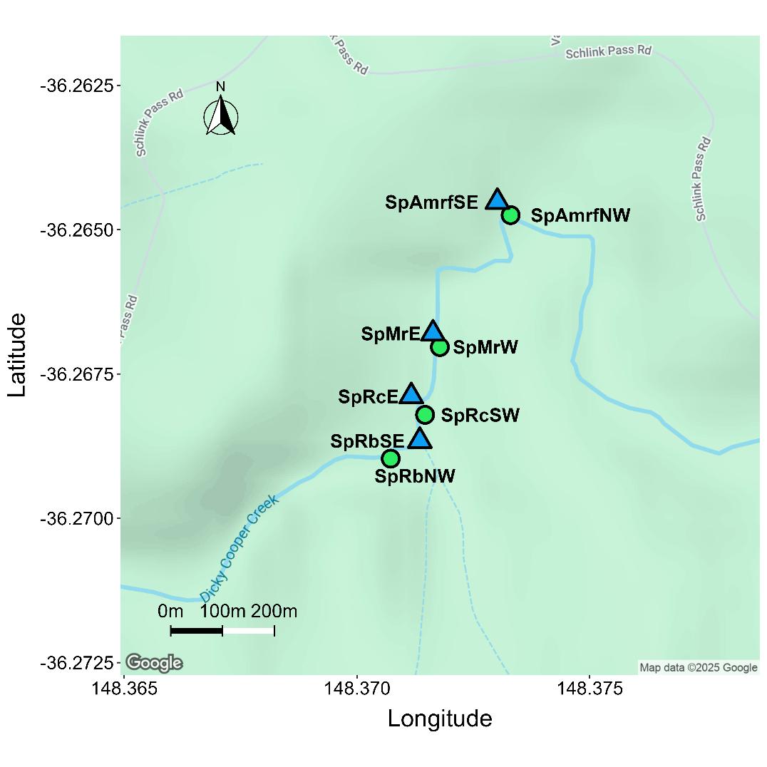  b  b\B\B
Figure 3. Maps showing the two study locations. Sites at the NW aspect are green circles, whereas sites at the SE aspect are blue triangles. Mt Stilwell pass (a) contains eight sites, four of the NW aspect and four of the SE aspect. Schlink Pass (b) contains the other eight sites, four NW and four SE (see main text in section 2.1 for allocation of sites to aspect category).

Sampling
Using a measuring tape reel, a 15 m transect was marked out at each site. Sampling took place within one metre on either side of the transect line, creating a 15 m x 2 m sampling plot. If the width of a plant extended beyond the 2 m buffer, its whole area was included in the sampling, as long as there were floral structures within the sampling plot. All flowering plants within the plot were identified, but for this dataset, I have only kept the ones that had a flower-visitor.
Observations of flower-visitors to all plants in flower within transects at each site took 10-30 minutes, with the duration mostly dependent on the number of plants in flower present in a transect. A flower-visitor (also referred to as visitor) was defined as any animal that physically landed on and interacted with the reproductive organs of a flower, namely the stamen and style (Ollerton et al., 2011). After a visitor was spotted, identification was made on the wing, i.e. not killed or removed from the site. Each visitor was identified as taxonomically close to family as possible, and lower for conspicuous genera and species. Morphological and functional traits were also recorded to help identify the species later. Each visitor was recorded in association with the individual plant/s it visited.

